Livestock Access Control

Project Name: Livestock Access Control

Location: Watershed wide
BMP Type and Description:
Access control is temporary or permanent exclusion of animals from riparian areas of streams.
Issues and Concerns:
Livestock with direct access to streams often deposit manure to those streams that causes nutrient and bacteria contamination, causes soil erosion of streambanks and elevates TSS concentrations in streams. Grazing in riparian areas of streams compacts soils and prevents the establishment of vegetation that can potentially filter the runoff.
Existing Conditions:
In some livestock operations, streams are the primary watering source for livestock, causing frequent, uncontrolled livestock access to and defecation in those streams. Livestock access to streams also degrades and creates channels for concentrated runoff. Soil compaction from grazing in riparian areas stifles growth of riparian vegetation; the latter filters pollutants from runoff in pastures.

Oblique aerial photos from Microsoft Bing Maps illustrate some of the current conditions in the Neshanic River Watershed. Livestock have open access to streams as indicated by the red arrows, which allows for direct deposit of manure in streams and streambank degradation. Access control fencing or a similar barrier would prevent livestock from defecating in streams. Re-establishment of riparian vegetation would reduce pasture runoff into streams. For such regeneration to occur, the fencing or barrier should be placed a minimum of 35 feet from the streambanks or more depending on site-specific conditions.
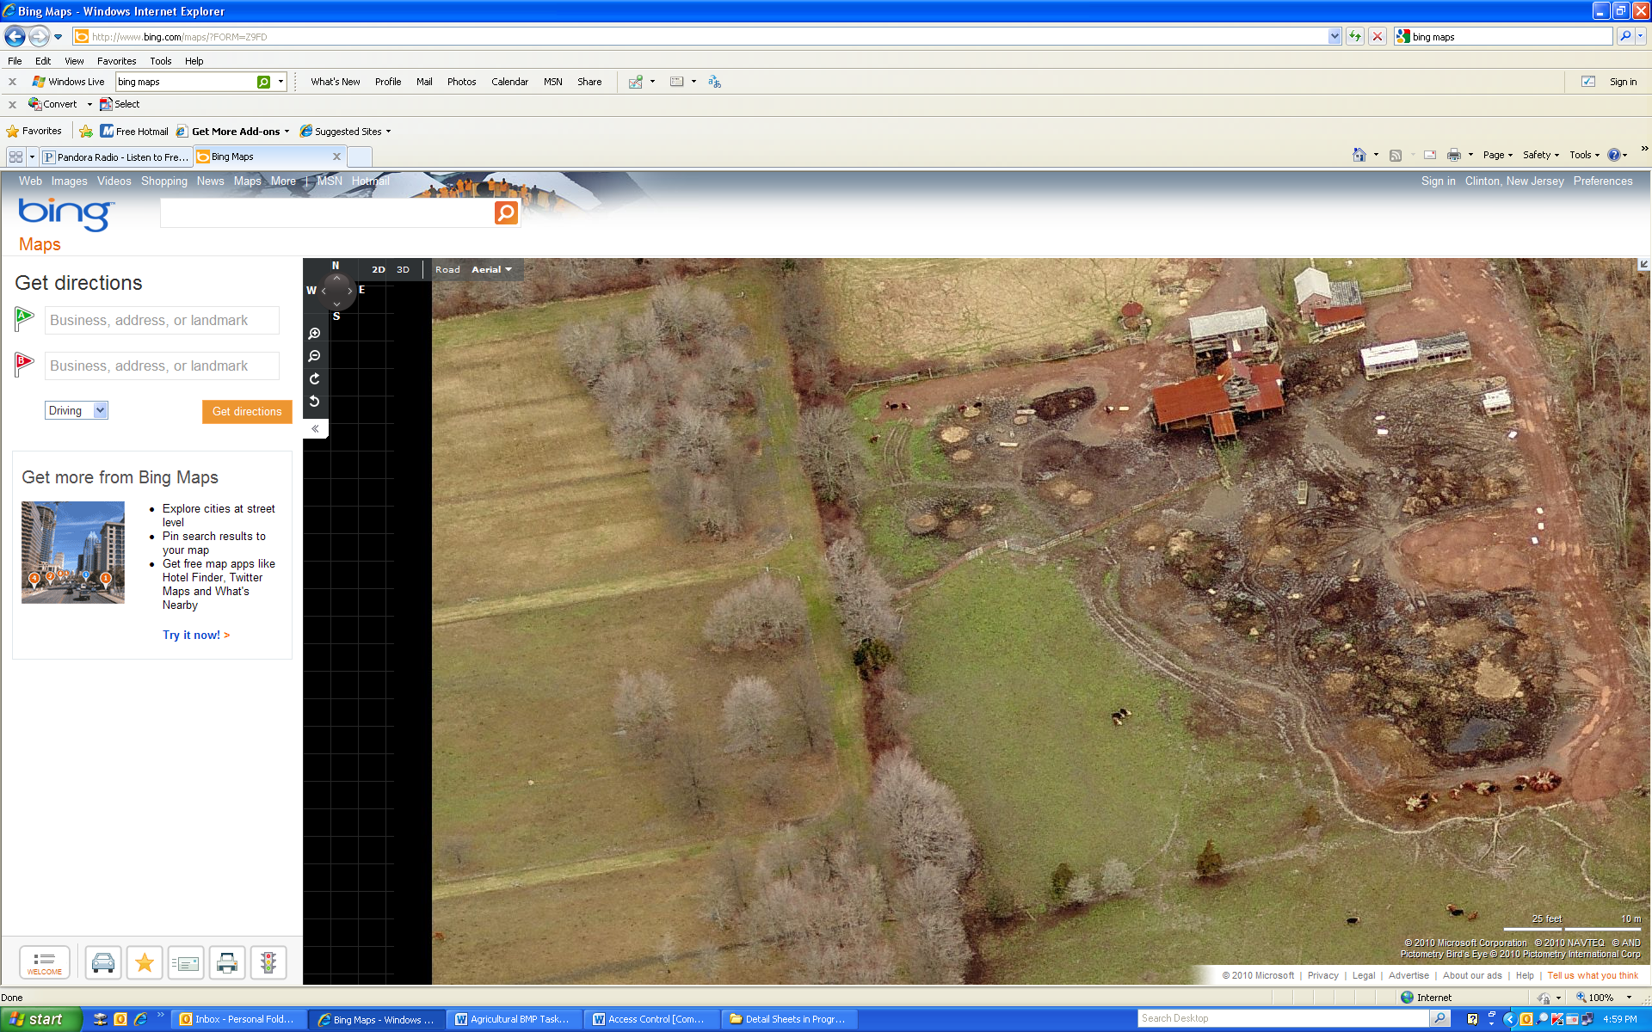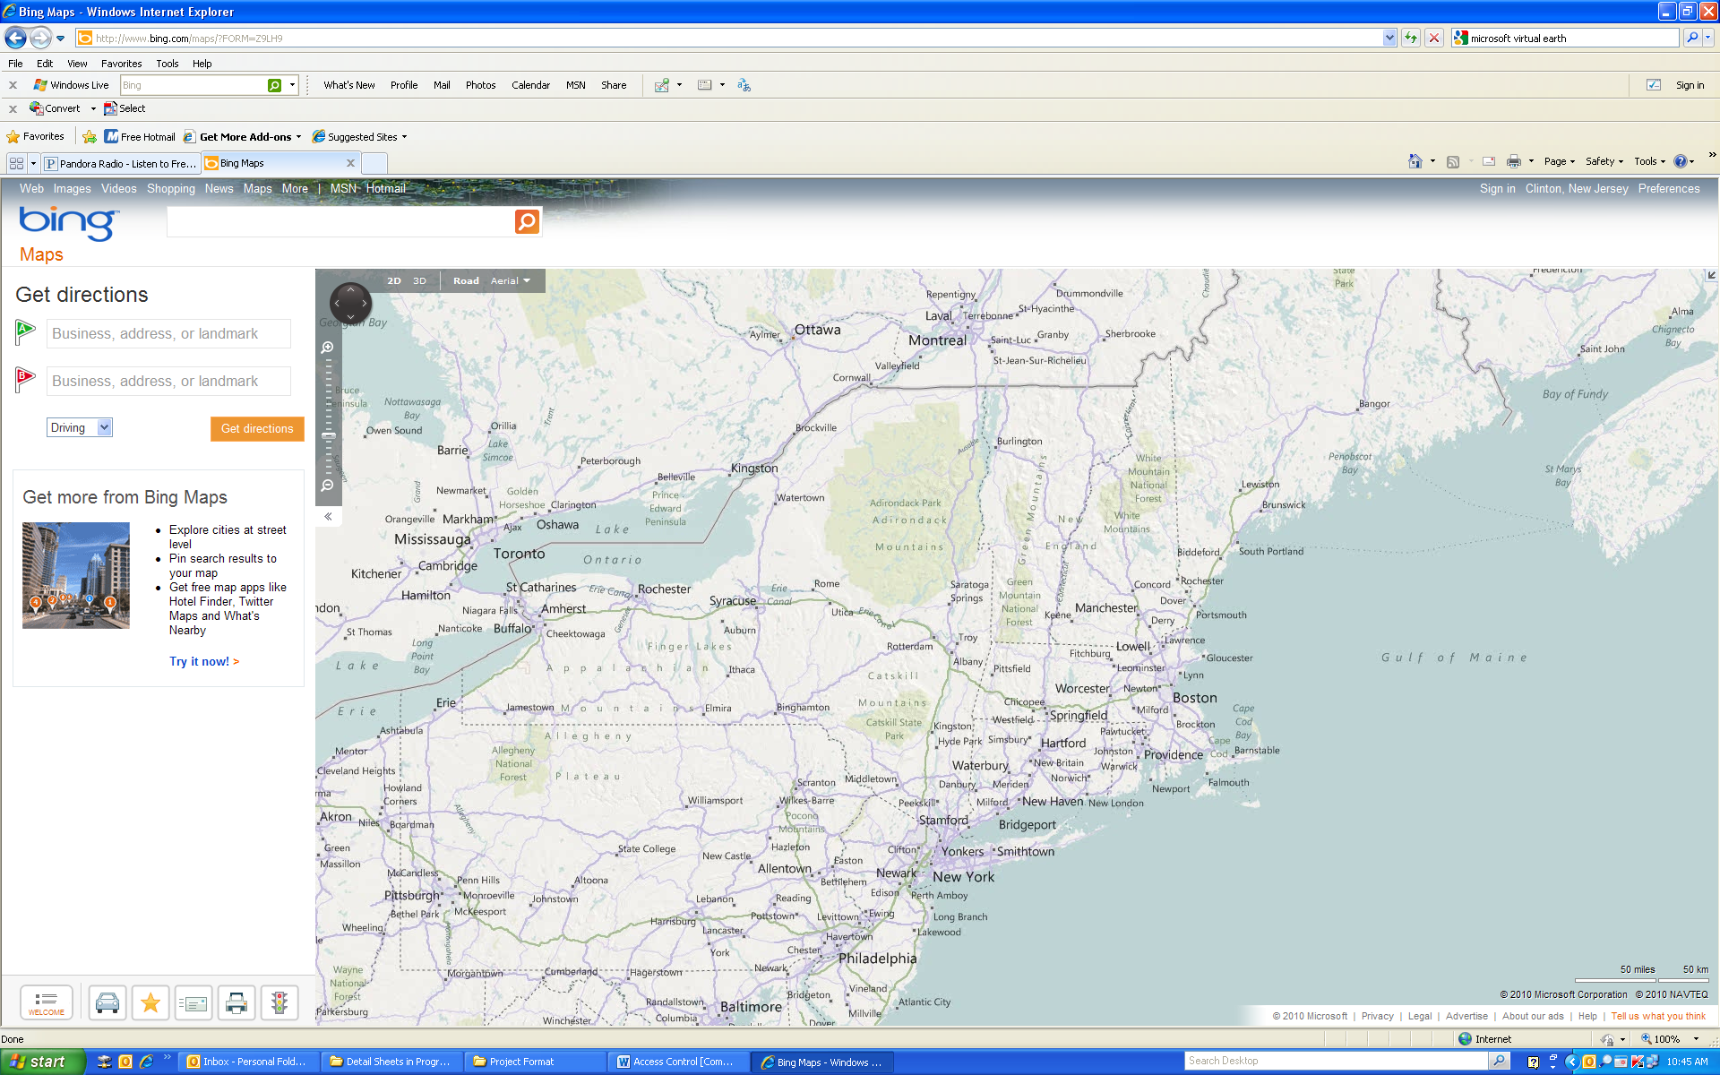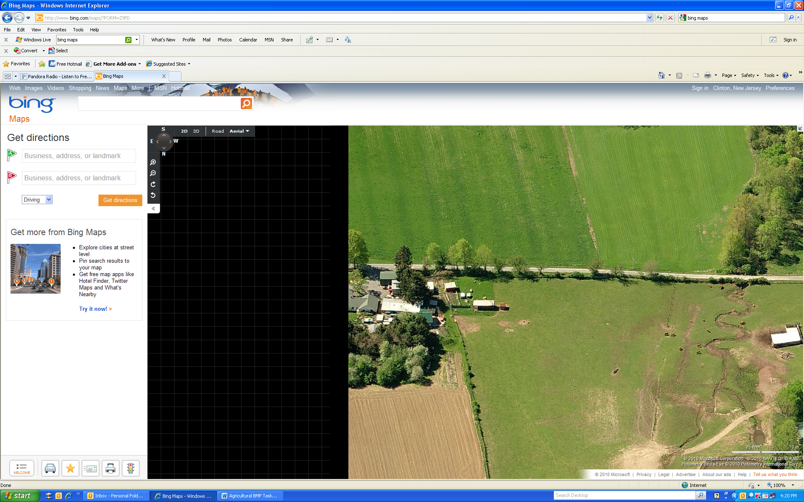

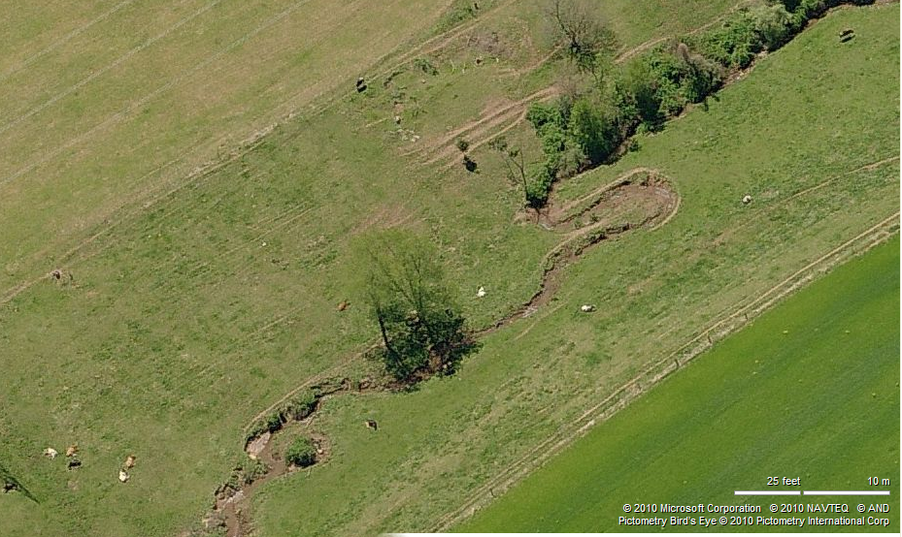

Proposed Solutions:
Exclusion fences should be used to eliminate livestock from access to streams and riparian zones in pastures. NRCS recommends the fencing be at least 35 feet from the streams. A greater distance may be required depending on site-specific conditions, such as land slope and intensity of adjacent land uses. NRCS New Jersey FOTG standards that may apply to livestock access control are Access Control (472), Fence (382), Stream Crossing (578), Watering Facility (614), Riparian Forest Buffer (391), Riparian Herbaceous Cover (390) and Filter Strip (393).
Anticipated Benefits:
Exclusion fencing will completely eliminate livestock manure from entering streams and permit the re-establishment of riparian vegetation that will filter runoff from adjacent pastures.

The SWAT model was used to simulate pollution loads in the Neshanic River Watershed. There are approximately 892 acres of pasture within the watershed, yielding approximately 1.70 pounds of TP per acre annually or 1,521 pounds per year for the watershed. The Chesapeake Bay Water Quality Model showed that access control fencing reduces TP by 60 percent. Applying access control fences along all streams that cross pastures would reduce TP loading by 1.02 pounds per acre or 913 pounds per year for the watershed.

The 892 acres of pasture in the watershed yield approximately 0.08 tons of sediment per acre annually or 70 tons per year for the watershed. The Chesapeake Bay Water Quality Model showed that access control fencing reduces sediment by 75 percent. This suggests that access control fencing could potentially reduce sediment loading in the watershed by 0.06 tons per acre or 52.4 tons per year for the watershed.
Major Implementation Issues:
This BMP will create new challenges for landowners in terms of requiring extra labor and learning how to maintain the BMP. Fencing must be routinely inspected and maintained, especially after flood events. Installing fencing would reduce the size of pastures, possibly resulting in a reduction in the number of livestock on pasture. In addition, excluding livestock from streams requires developing an alternative water source.
Possible Funding Sources:
EPA 319(h) through NJDEP, Private Sources, NJDA State Cost share, US Fish and Wildlife Service’s Partners for Fish and Wildlife Program, USDA Farm Bill Programs such as CREP, EQIP, AWEP, and other cost share programs.
Partners/Stakeholders:
Township officials; NRCS; NJRC&D; HCSCD; RCE; NJIT; NJWSA and SBWA
Task Description for a “Sample” Farm*
Task | Task Description |  |  | Cost
1 | Outreach to Producer |  |  | $1,000
2 | Technical Assistance |  |  | $500
3 | Project Plan |  |  | $200
4 | Implementation oversight |  |  | $200
5 | BMP Installation
 | Activities for BMP Installation | Unit Cost | Quantity
 | Fencing Installation | $4.78  per ft. | 500 ft | $2,500
 | Contingency (20%) |  |  | $478
 | Total BMP Installation Cost |  |  | $2,868
Estimated total project cost |  |  |  | $4,768
Annual Operation and Maintenance Cost |  |  |  | $100
* This “sample” farm is not indicative of every farm in the watershed. It is only a guideline used to estimate the cost of implementing access control fencing. The “sample” farm assumes that the only fencing needed is on one side of the stream and that there is an alternate, pre-existing water source for livestock. See the Livestock BMP sheet for a more detailed account of possible additional measures that may be needed when implementing access control fencing. Costs of BMP installation were estimated from the cost data in the New Jersey Farm Bill Program 2011 Practice Catalog. If program eligibility requirements are met, tasks 2, 3 and 4 may be provided at no cost to the landowner through NRCS technical assistance.

