Cover Crops

Project Name: Cover Crops

Location: Watershed wide
BMP Type and Description:
Cover crops include grasses, legumes, forbs or other herbaceous plants established for seasonal cover and other conservation purposes.
Issues and Concerns:
Exposed soil particles are vulnerable to being dislodged by rainfall and swept away. Eroded soil particles may carry phosphorus and other adsorbed contaminants to local waterways.
Existing Conditions:
The images shown below illustrate some of the current crop field conditions in the Neshanic River Watershed that contribute to water quality degradation. Seasonally, some crop fields have inadequate vegetative cover. Bare soil is susceptible to becoming dislodged and carried into streams by runoff during storm events. Suspended soil particles contain phosphorus and other contaminants. Erosion is indicated in the images below by the red arrows. Cover crops protect the soil particles from becoming dislodged, helping to reduce erosion and retain soil nutrients for future crop use.
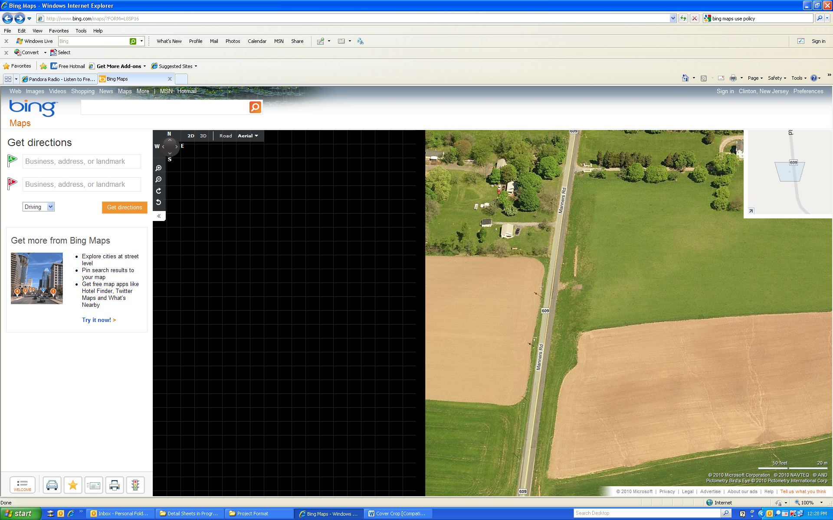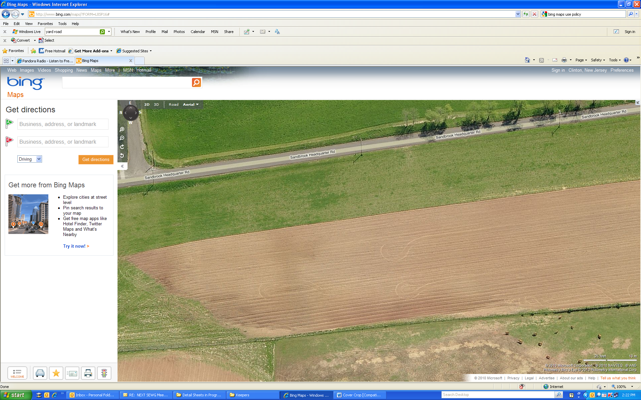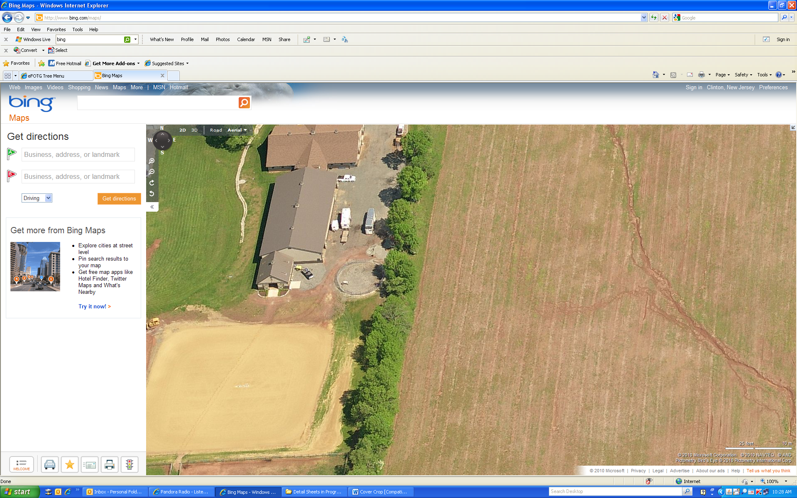

Proposed Solutions:
Cover crops would be planted on fields that are seasonally barren. Examples of cover crops are: Hairy Vetch (Visa villosa Roth), Winter Wheat (Triticum vulgare), Sorghum-sudangrass (Sorghum bicolor), Rye Grass (Lolium spp.) and Buckwheat (Fagopyrum esculentum Moench). The NRCS New Jersey Field Office Technical Guide (FOTG) practice code for cover crops is 340.
Anticipated Benefits:
Planting cover crops on barren fields reduces runoff, and wind and water erosion. Such crops absorb nutrients left from previous fertilizer and manure applications to the soil, making them unavailable for runoff. In addition, cover crops enhance overall soil health, reduce compaction and increase infiltration. Cover crops are especially beneficial in areas of the watershed where streams run dry during the summer.

The SWAT model was used to simulate pollution loads in the Neshanic River Watershed. There are approximately 4,011 acres of row crops in the watershed, yielding on average approximately 1.3 pounds of TP per acre annually for a watershed total of 5,223 pounds per year. The Chesapeake Bay Water Quality Model showed that early planting of cover crops reduced TP by 15 percent. Based on reduction rates determined by the Chesapeake Bay Model and assuming row crop acres are beneficial, indicates that cover crops would reduce TP loading in the watershed by 0.195 pounds per acre or 769 pounds per year for the watershed.

The 4,011 acres of row crops in the watershed have an annual average sediment yield of approximately 0.10 tons of per acre or 396 tons for the watershed. The Chesapeake Bay Water Quality Model showed that early planting of cover crops reduces sediment yield by 20 percent. Based on reduction rates determined by the Chesapeake Bay Model and assuming row crop acres reduce sediment loads, indicates that cover crops would reduce annual sediment loads by 0.02 tons per acre or 99 tons per year for the watershed.
Major Implementation Issues:
Use of cover crops involves a cost for materials and time. The time period between the harvesting of row crops and seeding of cover crops is very short, which may be problematic for some farmers. State and federal agencies have cost-share programs that cover some of the implementation cost of cover crops. In some cases, a cover crop can be harvested to generate additional revenue. There is also a cost savings when a cover crop provides nutrient credits for the subsequent crop.
Possible Funding Sources:
EPA 319(h) through NJDEP, Private, NJDA State Cost share, USDA Farm Bill Programs such as CREP, EQIP, AWEP, and other cost share programs.
Partners/Stakeholders:
NRCS; NJRC&D; HCSCD; RCE; NJIT; NJWSA and SBWA
Task Description for a “Sample” Farm*
Task | Task Description |  |  | Cost
1 | Outreach to Producer |  |  | $550
2 | Technical Assistance |  |  | $250
3 | Project Plan |  |  | $100
4 | Implementation oversight |  |  | $100
5 | BMP Installation
 | Activities for BMP Installation | Unit Cost | Quantity
 | Cover crop seeding | $83 average per acre for three years | 62 | $15,438
 | Contingency (20%) |  |  | $3,088
 | Total BMP Installation Cost |  |  | $18,526
Estimated total project cost |  |  |  | $19,526
* This “sample” farm is not indicative of every farm in the watershed. It is only a guideline used to estimate the cost of implementing cover crops. It is assumed that the sample farm has the equipment needed for field preparation and seeding of cover crops. The acreage for the sample farm is 62 acres, which is the average farm size in Hunterdon County (NASS, 2007). Cost of BMP installation was estimated using cost data from the New Jersey Farm Bill Program 2011 Practice Catalog. The unit cost is an average over five different seed types and plantings from the NRCS AWEP practice catalog. If program eligibility requirements are met, tasks 2, 3 and 4 may be provided at no cost to the landowner through NRCS technical assistance.

